**Deploying an Online Movie Watching Application on Cloud.**

You are working in an online entertainment provider company. As you have knowledge of cloud computing, you are asked to deploy the company’s website on cloud.

**Background of the problem statement:**

You work for Binge Watch Online, an online entertainment provider company.

You have created a website for the company and used a public cloud to deploy the website. After deploying it on cloud, users are complaining about the reloading speed of the pages. The website is getting global traffic and static assets like pages that are served from a single server. You need to make sure that the traffic coming to the website from different parts of the world is load balanced at the DNS level.

**You must use the following tools:**

* AWS: Route 53, S3 Bucket, CloudFront, EC2

Aws s3

Aws s3 is a storage services for creating a static website in order to sytore the information

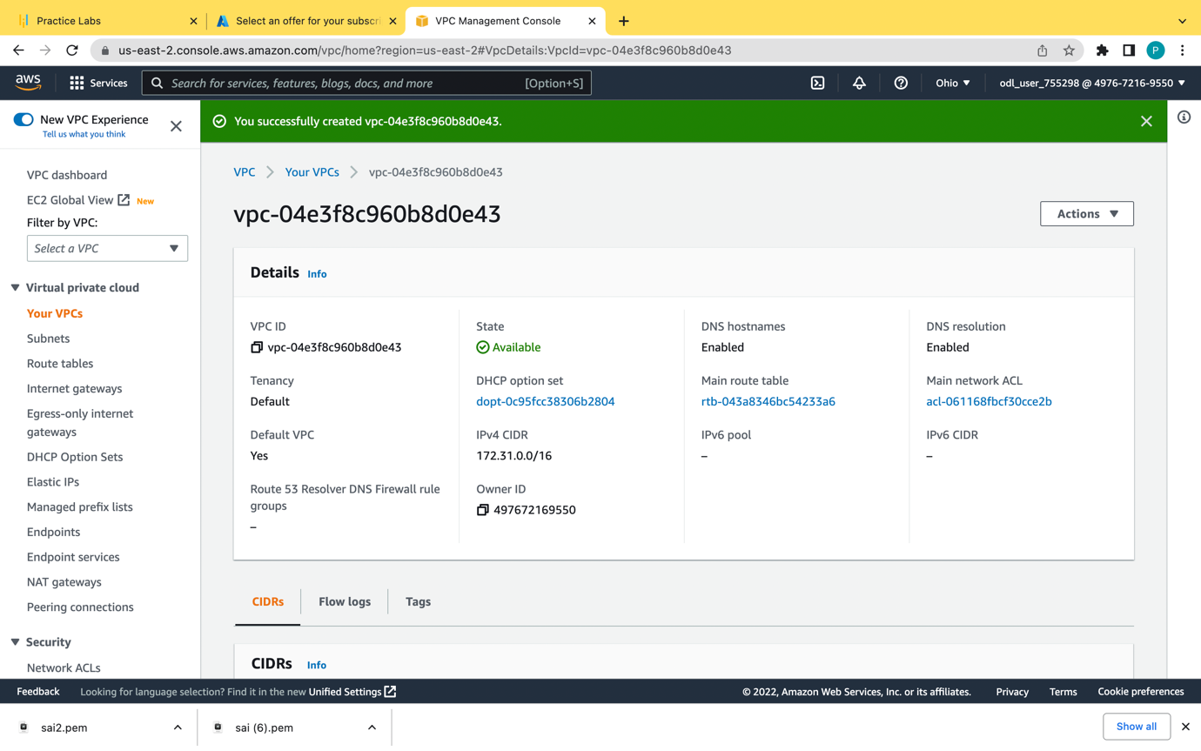

VPC is a virtual private cloud whether it can be created on different regions.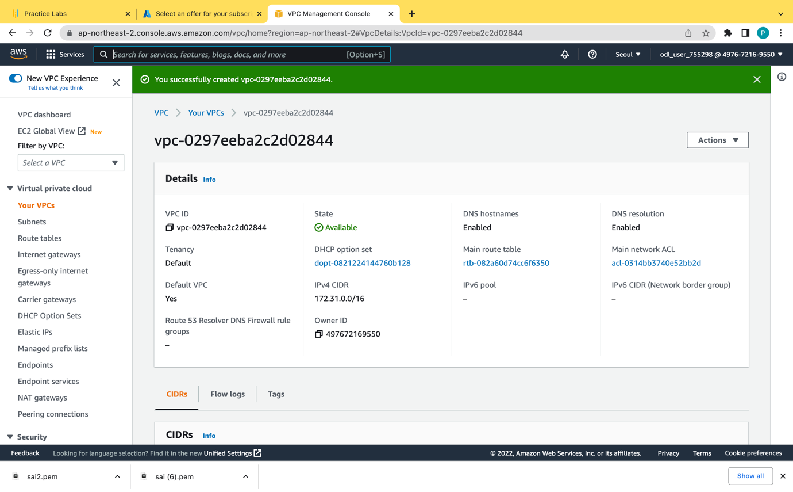

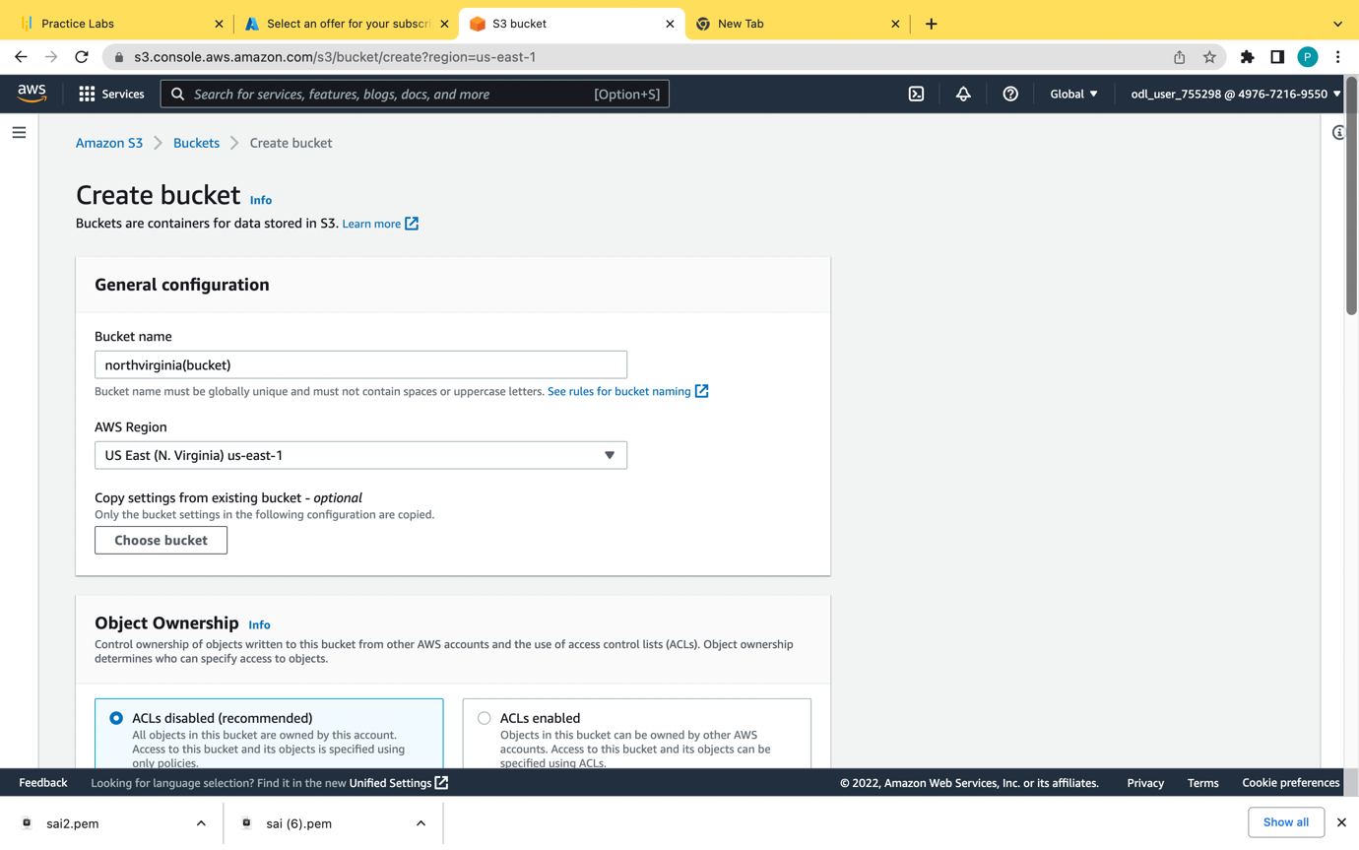

And we have to create the bucket in both the regions were we have created vpc and all the buckets should in ACL is enabled in all the buckets created for public access of the data

The bucket name and the route 53 record name should be same. 

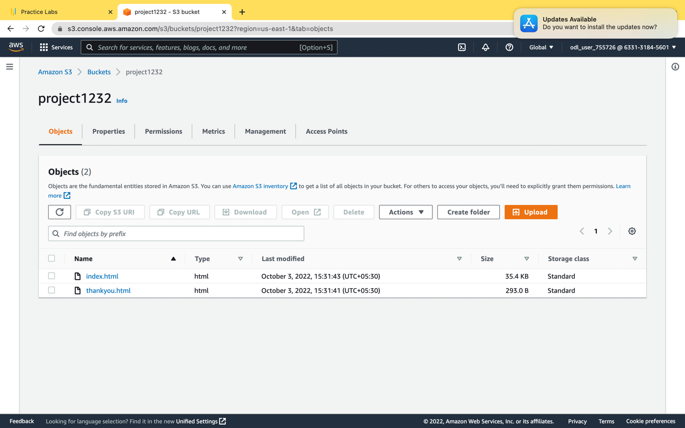

We have to upload the file called index.html in the bucket

In the actions go to the make public acl objects

Dns for hosting the domain name in the cloud front we have created a private hosted zone

For public we need a public domain name

And

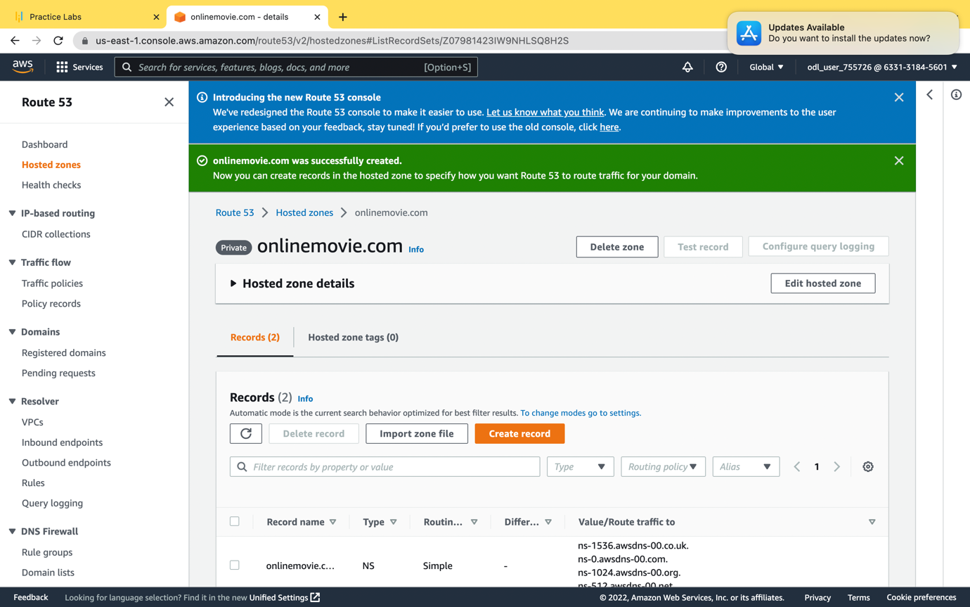

Before creating a record once check whether the static web hosting is enabled

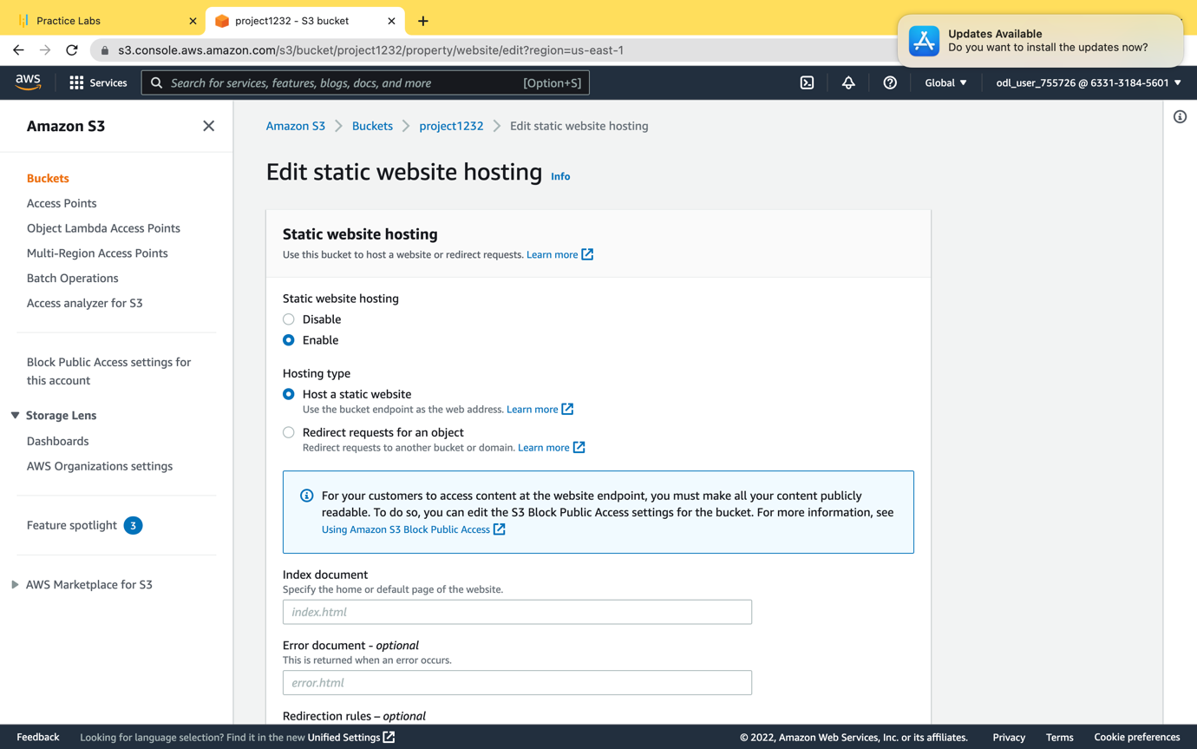

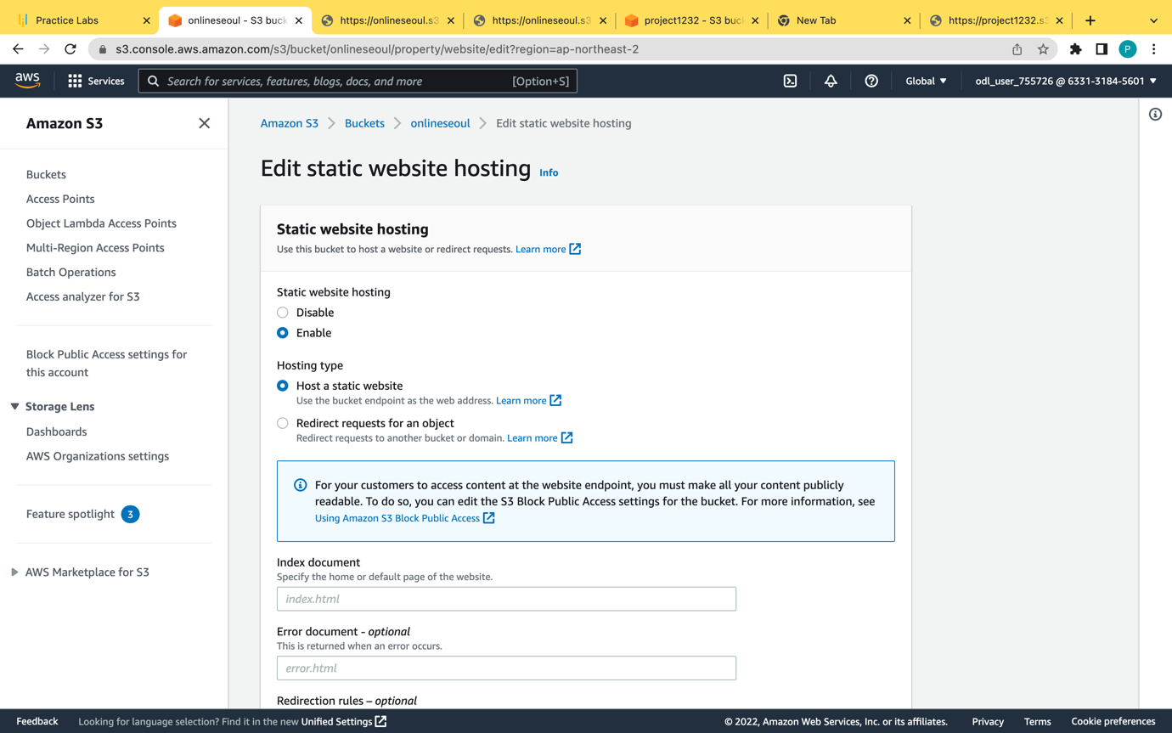

In the index document type index.html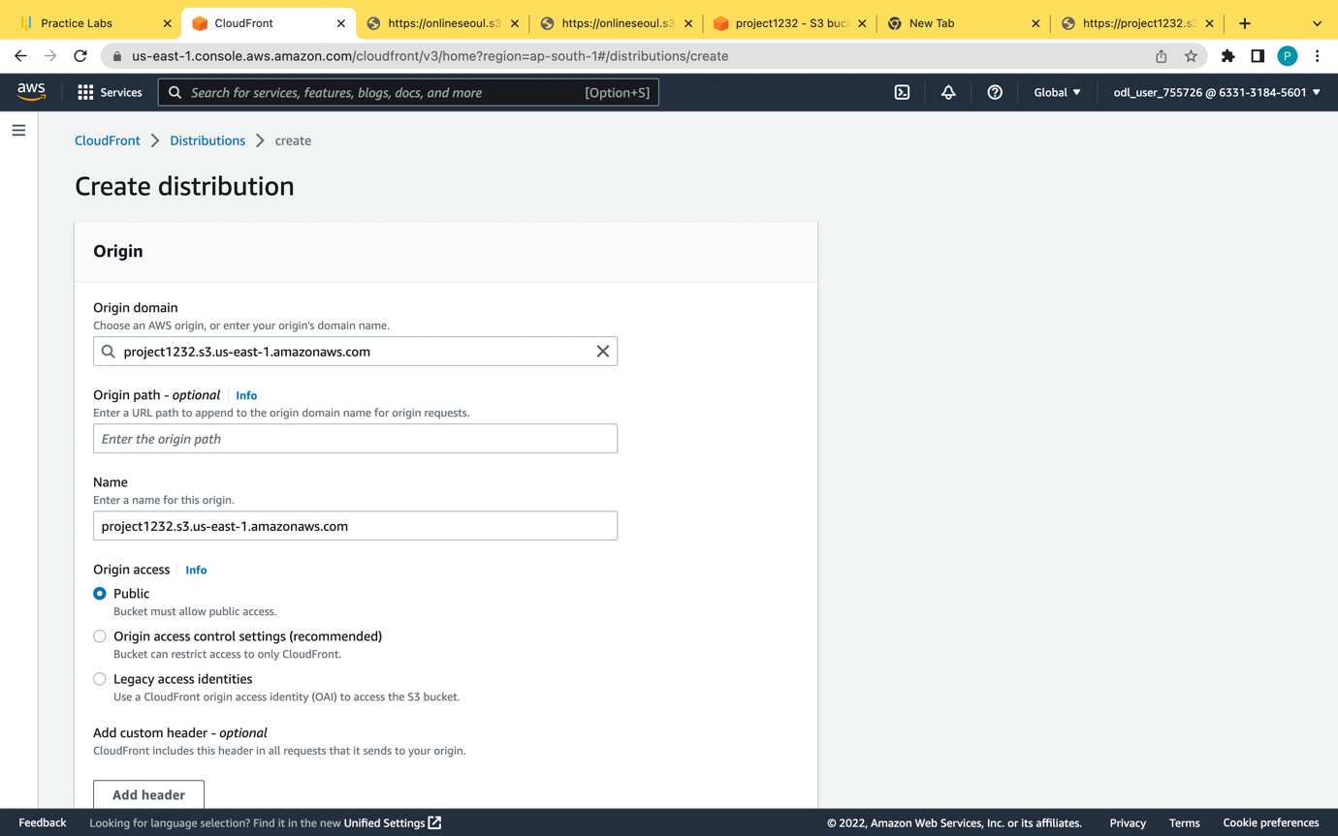

Before creating a record create a load front distribution

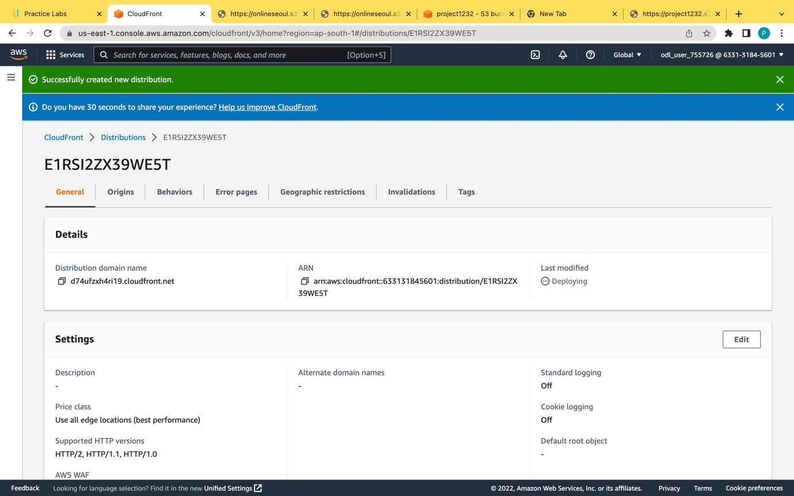

Distribution has been created in loud front

Atleast we have create two or three cloud front inorder to cach in edge location.

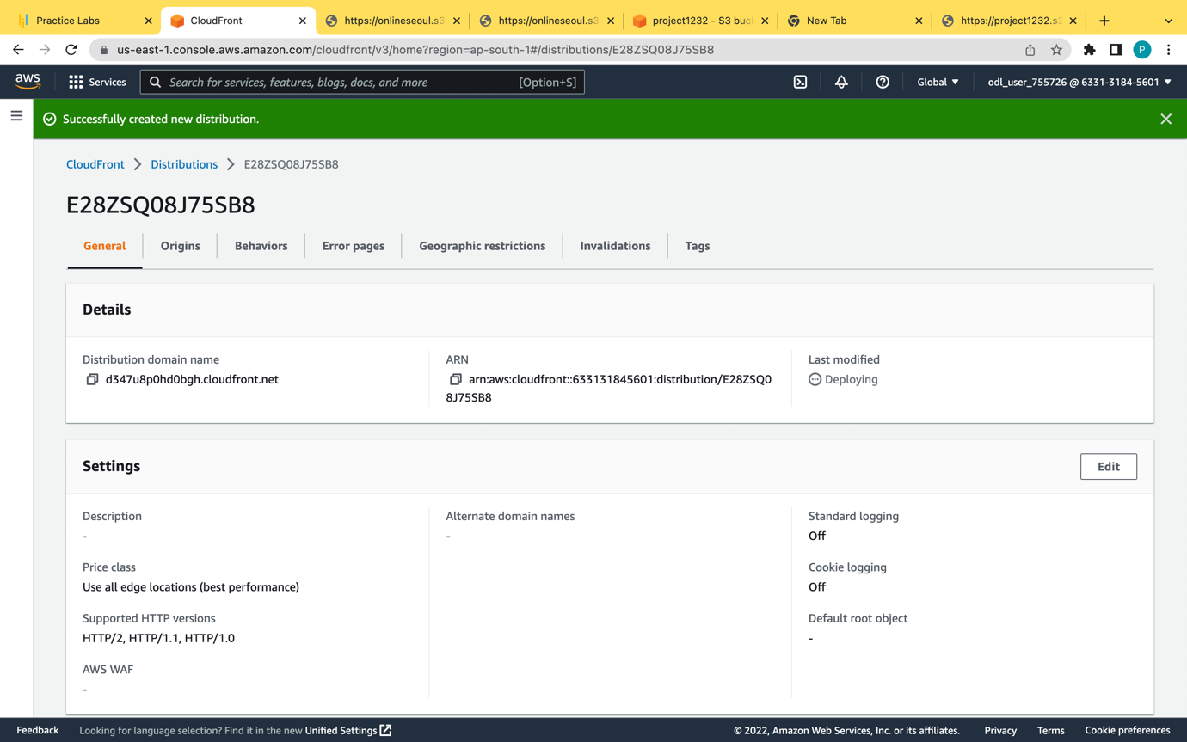

Two cloud front distribution as been created two cloud front if one fails other will work properly

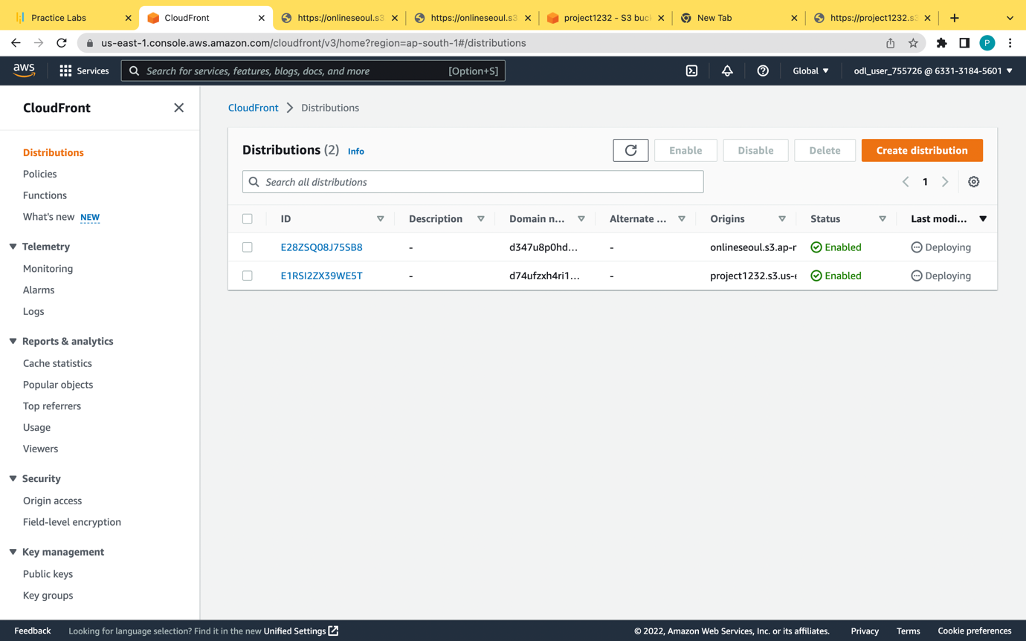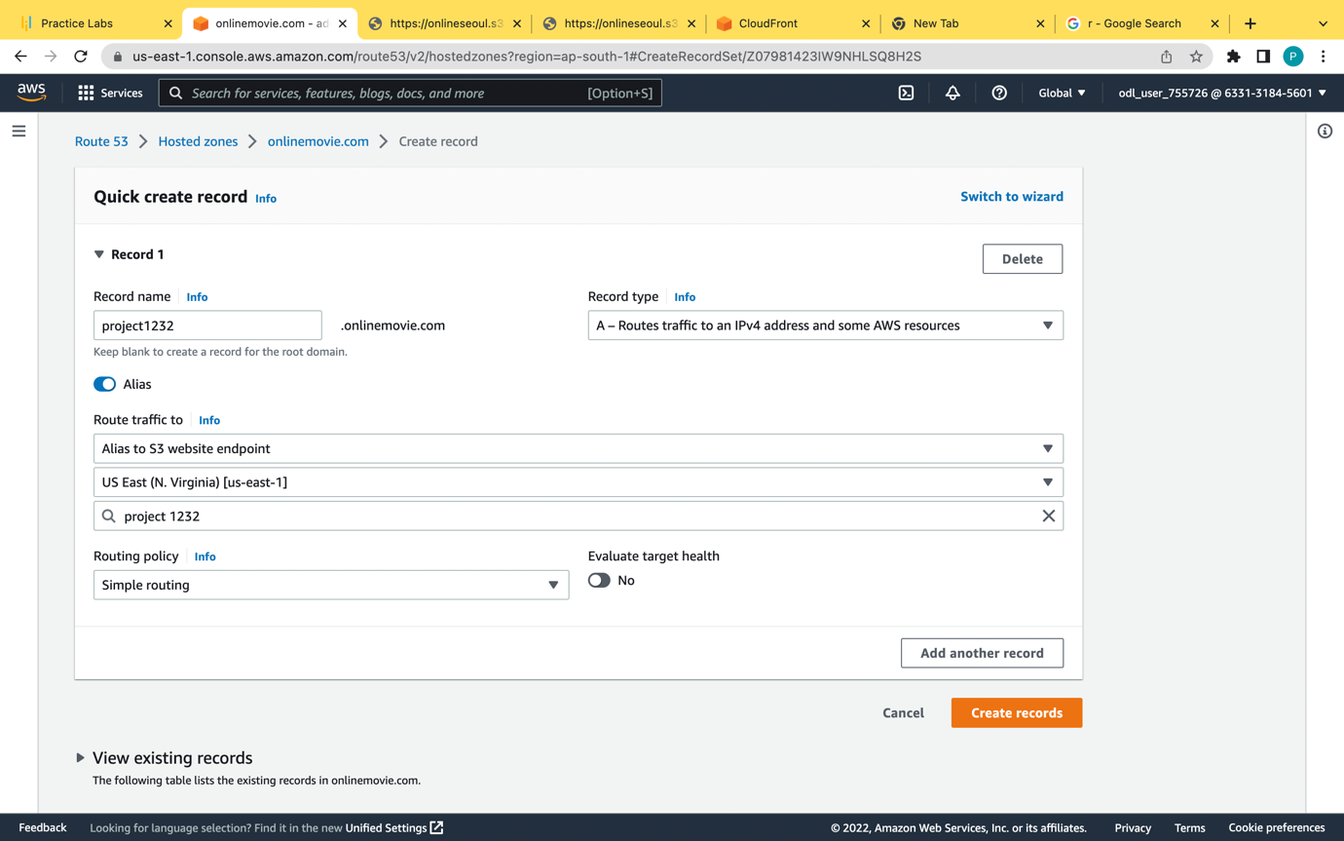

In the hosted zone create a record because record name and domain name should always atch the s3 bucket. Should be similar because alias cloud distribution or alias s3 website is used

For cloud front we need a public domain name for that only aws certification is available for the private domain name we can’t get the certification.

Alias s3 website endpoint we have create separate and separate record for that

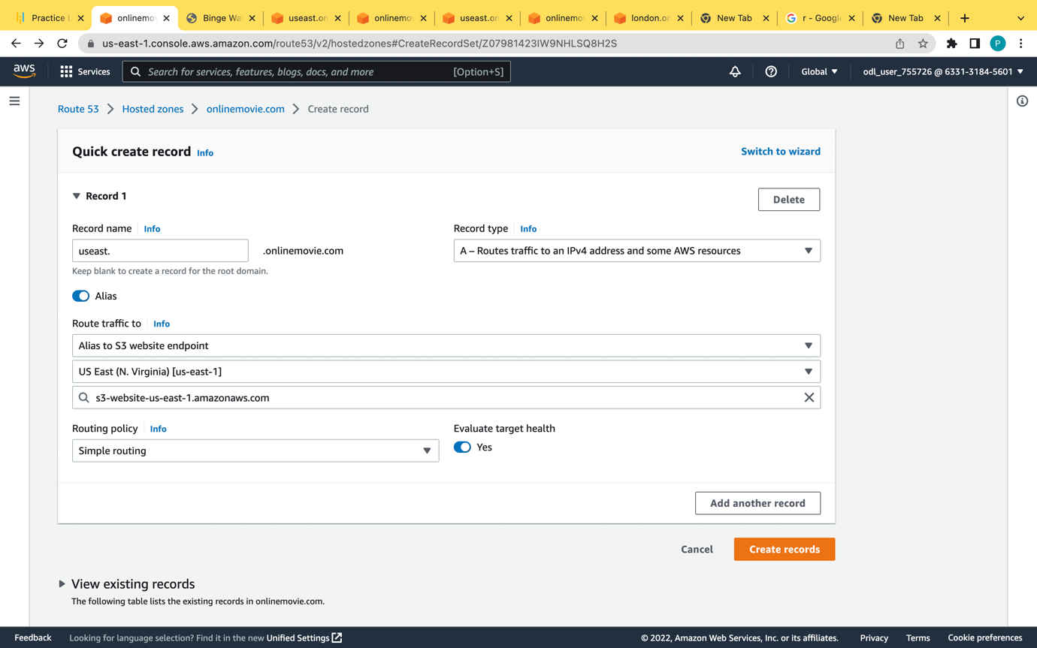

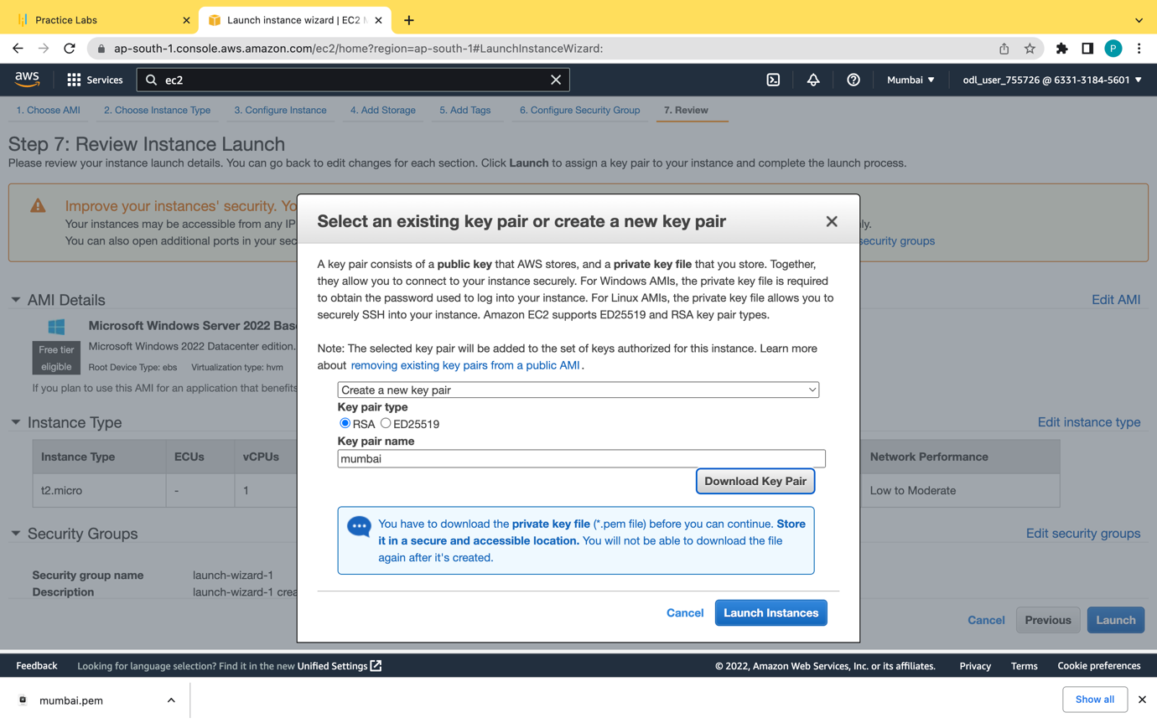

**It is private domain name so we have to run within the own virtual machine for that we have to launch two instances in windows. We have to check the Mumbai.onlinemovie.com**

**In that and check whether it is working**

